endures for eternal life, which the Son of Man will give you . For it is on him that God the Father has set his seal.’ Then they said to him, ‘What must we do to perform the works of God?’ Jesus answered them, ‘This is the work of God, that you believe in him whom he has sent.’ So they said to him, ‘What sign are you going to give us then, so that we may see it and believe you? What work are you performing? Our ancestors ate the manna in the wilderness; as it is written, “He gave them bread from heaven to eat.”’ Then Jesus said to them, ‘Very truly, I tell you, it was not Moses who gave you the bread from heaven. For the bread of God is that which comes down from heaven and gives life to the world.’ They said to him, ‘Sir, give us this bread always’. Jesus said to them, ‘I am the bread of life. Whoever comes to me will never be hungry, and whoever believes in me will never be thirsty.’

**Talk**

**Hymn 537: For the beauty of the earth**

**Prayers**

**Lord’s Prayer**

**Our Father in heaven, hallowed be your name, your kingdom come,**

**your will be done, on earth as in heaven. Give us today our daily bread. Forgive us our sins as we forgive those who sin against us.**

**Lead us not into temptation but deliver us from evil. For the kingdom, the power,and the glory are yours now and forever. Amen.**

**Hymn 532: All creatures of our God and King** *omit v.5 & v6*

**Blessing**

May God the Father of our Lord Jesus Christ,

who is the source of all goodness and growth,

pour his blessing upon all things created,

and upon you his children,

that you may use his gifts to his glory and the welfare of all peoples;

and the blessing ….

**Dismissal**

Freely you have received, freely give.

Go in peace to love and serve the Lord

**In the name of Christ. Amen**

**Parish of Capel and Ockley**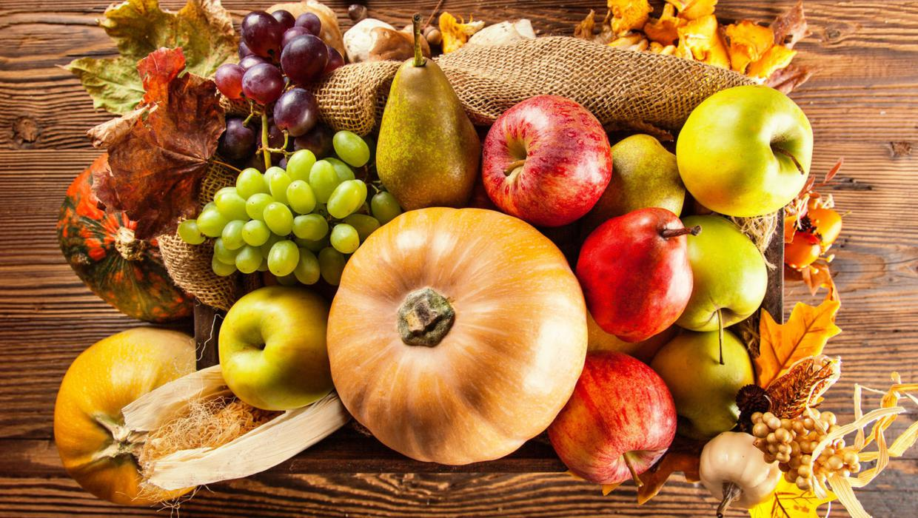

**St John the Baptist Harvest Festival**

**2nd October 2022**

**Hymn 290: We plough the fields and scatter**

*harvest goods may be brought to the altar*

**Prayer of thanksgiving**

Thank you, God, for your goodness that blesses us and the earth.

You are generous.

**Thank you, God.**

Thank you, God, for the people who made this food

and for those who will share in it.

You are generous.

**Thank you, God.**

Thank you, God, for this place, this village, this church

and for your faithful love over many generations.

You are generous.

**Thank you, God.**

**Help us to remember**

When we hear the gentle sound of the rain watering the earth,

**Help us to remember the thirst of those whose land is dry.**

When we feel the warmth of the sun on our faces

**Help us to remember the plight of those locked away in darkness.**

When we buy the fruit of the world’s harvest,

**Help us to remember those whose basket is empty.**

When we celebrate our blessings at harvest time.

**Help us to remember those who experience disaster.**

May our remembering stir our conscience

**and renew our commitment to Jesus and our neighbour. Amen.**

**Confession**

We confess to you our lack of care for the world you have given us.

Lord, have mercy.

**Lord, have mercy.**

We confess to you our selfishness in not sharing the earth’s bounty fairly.

Christ, have mercy.

**Christ, have mercy.**

We confess to you our failure to protect resources for others.

Lord, have mercy.

**Lord, have mercy.**

**Absolution**

May God who loved the world so much that he sent his Son to be our Saviour

Forgive us our sins and make us holy to serve him in the world, through Jesus

Christ our Lord. **Amen.**

**Collect for Harvest**

**Eternal God, you crown the year with your goodness**

**and you give us the fruits of the earth in their season:**

**grant that we may use them to your glory,**

**for the relief of those in need and for our own well-being;**

**through Jesus Christ our Lord. Amen.**

**Hymn 552: Think of a world without any flowers**

**Readings:**

Deuteronomy 26.1-11

When you have come into the land that the Lord your God is giving you as an inheritance to possess, and you possess it, and settle in it, you shall take some of the first of all the fruit of the ground, which you harvest from the land that the Lord your God is giving you, and you shall put it in a basket and go to the place that the Lord your God will choose as a dwelling for his name. You shall go to the priest who is in office at that time, and say to him, ‘Today I declare to the Lord your God that I have come into the land that the Lord swore to our ancestors to give us.’

When the priest takes the basket from your hand and sets it down before the altar of the Lord your God, you shall make this response before the Lord your God:

‘A wandering Aramean was my ancestor; he went down into Egypt and lived there as an alien, few in number, and there he became a great nation, mighty and populous. When the Egyptians treated us harshly and afflicted us, by imposing hard labour on us, we cried to the Lord, the God of our ancestors; the Lord heard our voice and saw our affliction, our toil, and our oppression. The Lord brought us out of Egypt with a mighty hand and an outstretched arm, with a terrifying display of power, and with signs and wonders; and he brought us into this place and gave us this land, a land flowing with milk and honey. So now I bring the first of the fruit of the ground that you, O Lord have given me.’

You shall set it down before the Lord your God and bow down before the Lord your God. Then you together with the Levites and the aliens who reside among you, shall celebrate with all the bounty that the Lord your God has given to you and to your house.

Philippians 4.4-9

Rejoice in the Lord always; again I will say, Rejoice. Let your gentleness be known to everyone. The Lord is near. Do not worry about anything, but in everything by prayer and supplication with thanksgiving let your requests be made known to God. And the peace of God which passes all understanding, will guard your hearts and your minds in Christ Jesus. Finally, beloved, whatever is true, whatever is honourable, whatever is just, whatever is pure, whatever is pleasing, whatever is commendable, if there is any excellence and if there is anything worthy of praise, think about these things.

**Hymn 283: Fill your hearts with joy and gladness**

Gospel reading: John 6.25-35

They found Jesus on the other side of the Lake and they said to him, ‘Rabbi, when did you come here?’ Jesus answered them, ‘Very truly, I tell you, you

are looking for me, not because you saw signs, but because you ate your fill of the loaves. Do not work for the food that perishes, but for the food that