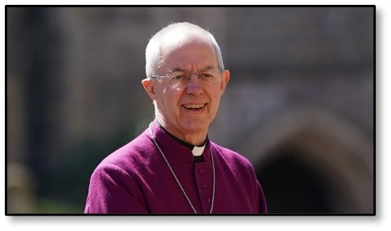

The Archbishop of Canterbury’s Visit to the Guildford Diocese

24th-27th September 2021
In late September, Archbishop Justin Welby will be visiting the Guildford Diocese.
From 24th-27th September the archbishop will be attending various events to which any
members of our congregations are invited, and for us to invite guests to hear a message
about faith in Jesus Christ.
There are two different events. One is for church members, and one is for guests, so please
read carefully.

An Evening with Justin Welby

All church members are invited to come to an event on:

Friday 24th September 8pm at the Lakeside Centre, Camberley,

where he will speak on the future of the local church and take part in an extended Q and A session. This will be a time of encouragement, support and thanksgiving for all that parishes have been doing during the pandemic. This event is aimed first and foremost at existing church members.

You can book now: www.eventbrite.co.uk/e/an-evening-with-justin-welby-tickets-160856571335

The Big Questions Event
The archbishop will be visiting each deanery for a Big Questions Event, to which we can invite guests who we feel may like to hear about the Christian faith in a ‘non-churchy’ way. This is a time of great opportunity as people emerge from a pandemic which has shaken the foundations of our worldly security. They are wrestling with uncertainty, asking big questions and increasingly open to faith. The archbishop will spend most of his time responding to questions, which he does with candour and humour, and we are confident that this will engage our audiences and encourage them to explore the source of his hope, faith in Jesus Christ. No question will be ‘off limits’.
The Big Questions event for the Dorking Deanery will be on:
Saturday 25 September at 11.30 at Dorking Halls
You can book a place here: https://www.eventbrite.co.uk/e/big-questions-with-the-archbishop-of-canterbury-dorking-tickets-162238043355

