Rotawalk’21
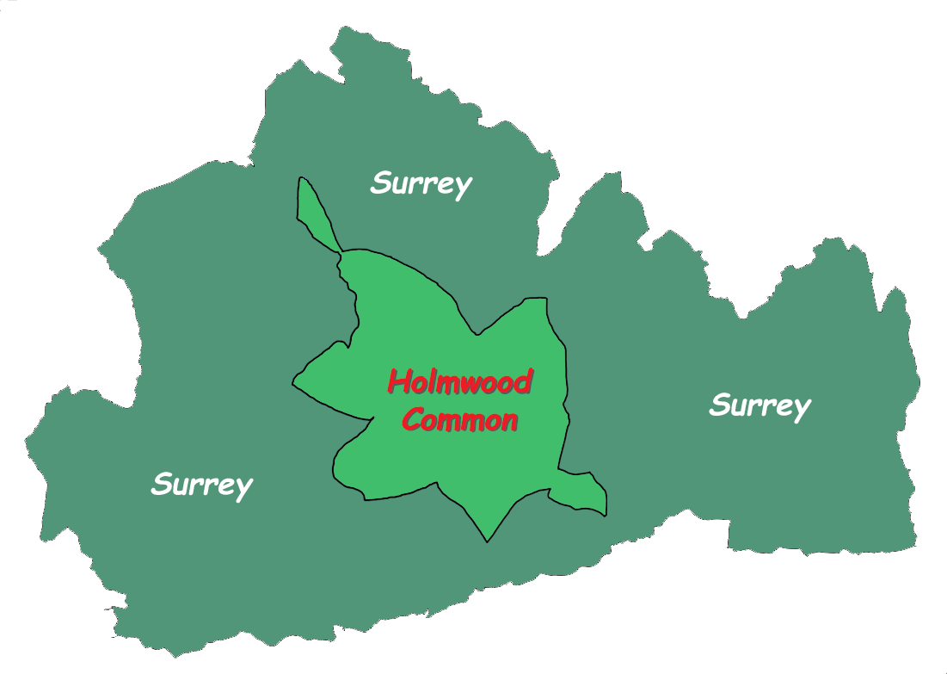
Capel and Ockley PCC

Sunday 12th September 2021

Sponsored walk around Holmwood Common (5 miles south of Dorking) …
… and help to raise funds for Capel and Ockley Churches

This lovely walk on land once owned by King Harold and managed by the National Trust since 1955 will take you through mixed woodland to discover sunny glades and numerous ponds: a haven for wildlife of over 650 acres.
Organised by
Rotary in Dorking

Event Details - overleaf
- Start and finish: Starting from Four Wents Pond Carpark on Sunday 12 September afternoon. Nearer the time we will sort out car sharing for those who would like a lift.
- Route: 3.5 miles around a flattish, cinder-based all-weather circuit, suitable for all ages, and easily negotiated with push-chairs and mobility scooters.
- Attractions: You will enjoy a ‘Virtual Tour’ around the borders of Surrey, with information boards on 12 well-known locations, with a quiz question at each one. Also, a Nature Quiz for the younger walkers.
- Refreshments Do join us afterwards at Capel church for a church tea in celebration of all your hard work.
- Covid-19: The walk will be compliant with all Covid-19 guidelines in effect at the time. Any special arrangements will be advised to participants at least a week before the event.
- Registration fee: We are asking each adult walker to raise at least £20. £5 of this will go to the Rotary Club for organizing the event the rest will help towards your churches upkeep.
- Sponsorship: We would be delighted if you would like to raise more than £20, we can issue you with a sponsorship form for this.
- Dogs: Please keep your dogs on a lead for this event, and pick up any dog poo.

- Registration: Please register by contacting us via: Debbie von Bergen debbievonbergen@icloud.com 07774784008

