Deny yourself and take up your cross
Sermon preached by Bishop Jo for the Diocese of Guildford, Lent 2, 28th February 2021

Mark 8:31-38
31 Then Jesus began to teach them that the Son of Man must undergo great suffering, and be rejected by the elders, the chief priests, and the scribes, and be killed, and after three days rise again. ³²He said all this quite openly. And Peter took him aside and began to rebuke him. ³³But turning and looking at his disciples, he rebuked Peter and said, ‘Get behind me, Satan! For you are setting your mind not on divine things but on human things.’
34 He called the crowd with his disciples, and said to them, ‘If any want to become my followers, let them deny themselves and take up their cross and follow me. ³⁵For those who want to save their life will lose it, and those who lose their life for my sake, and for the sake of the gospel, will save it. ³⁶For what will it profit them to gain the whole world and forfeit their life? ³⁷Indeed, what can they give in return for their life? ³⁸Those who are ashamed of me and of my words in this adulterous and sinful generation, of them the Son of Man will also be ashamed when he comes in the glory of his Father with the holy angels.’

In her retirement my mother has researched, written and self-published a family history. It’s a wonderful gift to the grandchildren and a mine of anecdotes on everything from wartime rationing to the Lancashire cotton industry. Most striking amidst the stories are the values they embody, values that define the family from one generation to another. In every generation it’s striking to see how parents have made great sacrifices, even taken on great suffering, so their children could have a better life. For example, after the first world war, my grandparents worked dangerously long hours, in one case costing their health, so the children could get to a “good school” – and stay in school - and have the kind of education that they themselves were denied. In order to guarantee them a better future.
It’s easy for us to think of Jesus in this way: dying on the cross, accepting a depth of suffering and pain, so that those who believe in him may have not only eternal life but also a better and more successful life. We want to think that Jesus died on the cross so that we would not have to.
But Jesus’ words in Mark 8 remind us that Jesus does not think like my grandparents. Jesus says, “Whoever wants to be my disciple must deny themselves and take up their cross and follow me.”
In other words, Jesus did not die on the cross so that we would not have to. Jesus died on the cross and asks that we would be willing for that too, if circumstances came to it. That we would choose to do likewise.
And Jesus isn’t calling us to take up our cross temporarily or in a one-time deal. It’s ongoing. In Luke’s version of these words, Jesus calls us to take it up daily. This isn’t just a strategy for lockdown, for enduring difficult times while we wait for God to resurrect us to greater blessings in this lifetime – you know, until we’ve all got the vaccine. He is calling us to lose our lives permanently for his sake and the sake of the gospel. Quoting a contemporary Orthodox priest, “The life of the baptized [Christian]…is one of ‘learning to die.’”
What does that mean, what do we need to learn, in order to deny ourselves and take up the cross of Christ?
On the basis that sermons are always chiefly for the benefit of the preacher, then here we go. (The reality is that it feels I’m better qualified to preach on how to deny the cross and take up my self than I am to preach on how to deny myself and take up the cross)
Yet Jesus says that denying oneself and taking up the cross are basic daily requirements for all disciples. For most of us, there’s no one big moment presented to us where we take up the cross once and for all. Instead, every day and every hour, in every action and every conversation for our entire lives, we have the choice: whether we will deny ourselves or deny the cross. The decisions we make in each moment add up to a whole life direction—one that either leads toward the cross or away from it. Even when we fail to deny ourselves and take up the cross in one moment, we are immediately faced with the same decision again the next.
Do you note the order of these two invitations: to deny yourself, and to take up your cross. First, we empty ourselves of something: our self. Then, once we have emptied ourselves, we have capacity to take on something: the cross. We can’t carry both. We can’t have two masters, as Jesus says, or we will hate the one and love the other. For as long as we’re prioritising the self, we’ll resist the cross.
What might it mean to create the space to carry the cross in our lives and hearts? Here goes: I want to dare to name three kinds of self-denial.
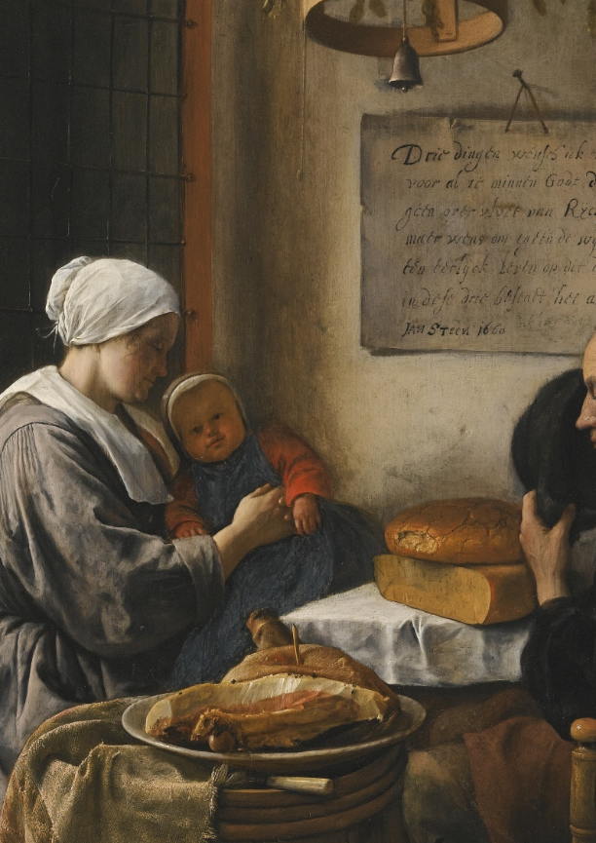
The first has to do with denying ourselves some delight or pleasure - the kind of self-denial we tend to work at in Lent, giving up chocolate or wine or whatever. A friend and her family have committed to a sugar-free Lent. It’s a good idea to begin with the external forms of self-denial – they’re the starting points from which we work inwards. Clement of Alexandria said, ‘Dying to ourselves means being content with the necessities of life. When we want more than these necessities it is easy to sin.’ I think of that beautiful C17 Dutch painting by Jan Steen, ‘Prayer before the meal’ where they’re pausing to give thanks for the absolute basics. As Paul wrote to Timothy:
If we have food and clothing, let’s be content with that. Those who want to get rich fall into temptation and a trap and into many foolish and harmful desires that plunge people into ruin and destruction. (1 Tim 6:8-9)
So our dying to the delights and pleasures of life is a necessary part of denying self, a beginning.
But as Jesus says, it’s not what goes into us that’s the real problem; it is what comes out of us from the inside (Matt 15:11). How do we appropriately work on self-denial from the inside?
I want to say a second step might be to work on getting over ourselves. Getting over our need for attention. Getting over some perceived criticism from a colleague. Getting over some deep frustration that niggles and vies for our attention. I wonder if we might practice ignoring those things, even ask our partner or a close friend to help us with that. Ignoring them isn’t about growing a thick skin: it’s about the will, about choosing to set aside what others think of us in order to be more alive to what Christ might be thinking. To be freed from our self-preoccupations in order to be more fully present to God.
Finally I’m going to dare to suggest a third mode of self-denial is about dying to our self-trust. If our self-will is fallen, then it’s most likely to deceive us precisely at the moments when we are most convinced we see clearly. I suspect we Christians have a tendency to presume that in being saved our judgment has somehow been healed, and functions better than that of others.
Paul challenges the Corinthians on this. Even in extreme situations like being sued in court by a fellow Christian, he asks “Why not rather be wronged? Why not rather be cheated?” (1 Cor 6:7). When he’s writing about conflicts between believers over some aspect of Christian practice, he says, “Who are you to judge someone else’s servant? (Rom 14:4).
Self-will is the source of most conflict in the world, certainly in the church. God doesn’t heal our self-will and then re-deploy it so that we can bless the world with our improved judgment: God heals the world by crucifying our self-will.
I’m sure God’s gift of marriage is important here. Let me tell you, no one knows my self-righteousness, my self-trust, more than my husband. In any given challenge, I can be relied on to mount a self-defence in milli-seconds. So let me recall a quote that stuck from a magazine article a few years back: ‘no matter how certain we may be that we are right and our spouse is wrong, our greatest marital problem is ourselves.’

And so Christ graciously invites us to deny ourselves in order that we may take up a cause that is far more worthy and worthwhile. I invite you to reflect this Lent on your journey of discipleship. There are no A level exams in self-denial – sorry, it’s more like continual practice and assessment, where every little helps – in order that we may grow beyond the preoccupations of that little kingdom of the self and into the spacious freedom and fullness of the kingdom of God.
It would be wonderful to think that if and when someone comes to write our Guildford diocesan family history, amidst the anecdotes on everything from constructing a cathedral in time of recession to creating online community in time of pandemic, that our stories would embody a set of values that persist from one generation to another, like the grain of wood in a tree: of how those Christians made great sacrifice, how they denied themselves, not for self-preservation, not so their children might have a better life, not for their reputation or even to make a wise investment, but so they might better be able to take up their cross and follow our Lord. All the way.

John Behr. 2013. Becoming Human. Yonkers, NY: St. Vladimir’s Seminary Press, p. 64-66.
Lynn Roush. 2010. “Marriage: A Dying to the Self.” Christianity Today. http://www.christianitytoday.com/women/2010/may/marriage-dying-to-self.html.

