A Christmas Reflection based on the Bidding Prayer from 9 Lessons with Carols
Liz writes: This is something that a clergy friend has written and reflects on her experience of the annual nine lessons and carols services so many of us enjoy. Reverend Gillaine Holland is the vicar of St Michaels Shared Church in Sheerwater, Woking. I thought you might enjoy what she has given us and the beautiful painting by her father, artist Paul Robertson. Gillaine herself is also a talented artist as well as priest! For our purposes we are only able to share the first of four reflections and paintings but here it is:
‘Every Christmas, in every church I have ever been part of, there has been that magical moment where we snuggle down into our seats (whether wooden pews or comfy chairs) under the warm glow of candles. Every year there was some kind of debate over whether it was better to have just candles (and limited reading ability) or some electric light (and the ability to read the order of service and join in with gusto! St Michaelʼs is no exception but, with the advent of screens (see what I did there), we usually manage a happy compromise. As the lights are dimmed and the choir arrives and (in many churches) a young lad sings those familiar words, ‘Once in royal Davidʼs city stood a lonely cattle shed...ʼ we are transported to Bethlehem to ‘hear again the message of the angels... and see this thing which is come to pass, and the Babe lying in a manger.ʼ These are the opening words of the service of 9 lessons with carols which was first drawn up by Edward Benson (Bishop of Truro) for use in his cathedral. It was simplified and adapted for use in the chapel of Kingʼs College, Cambridge, in 1918 by the Dean, Eric Milner- White, who wrote the Bidding Prayer that these paintings are based on.
Part of our Robertson family tradition began around September with my parents, Paul and Pauline Robertson, discussing ideas for decorating our church, St Patʼs, in Wallington. They would pray and sketch and eventually head to the Minister with a theme for decorating the building over Advent and Christmas. Then, over the following months, paintings or paper sculptures would gradually emerge from my fatherʼs studio, slowly taking over other parts of the house as the collection grew, while my mother wrote the reflections that accompanied them. Collaborating over each festival was a costly gift to the church family that spanned many decades. Some of the collections were less sturdy than others and have long since been recycled, whilst others remain in my care. This collection is simply 4 paintings which illustrate the bidding prayer and invite us to travel again to the stable in order that we might pray. A word about the words themselves: they are beautiful but old-fashioned. We donʼt all read at the same level and so Iʼve unpacked the language a little in the reflection but if words get in the way then look at the pictures – after all, that was the whole point of church art in the first place. The pictures tell the story without the need for words.
This year things are very different: we have not sung together (live) since March. We have to wear masks and sanitise. We cannot hug, shake hands or greet each other with a kiss. We cannot even stop and chat or drink coffee. The windows in church have been open and it was getting cold. I say ‘wasʼ because Iʼm editing this having heard the news that we are now in tier 4, Christmas bubbles are cancelled and although worship is permissible, we are being asked to act as if we all had the virus. In our fragile community, we have taken the heart-rending decision to close the St Michaelʼs building and return to Zoom, cancelling the exhibition of these paintings and the carols alongside them. Christmas may not be comfortable or cosy this year; we canʼt have our traditional carol services in quite the same way but the invitation of this beautiful prayer can still transport us to Bethlehem and invite us to meet Jesus in prayer, as in any other year. I hope these 4 pictures and the reflections with them, will conjure up images of Christmases past and future but will also call us into this Christmas; to be present in this time and this place and to pray for our world in the middle of this Covid pandemic.May God bless you in this strange season as we journey on - Gillaine’
Painting 1: an invitation to journey
‘Beloved in Christ, be it this Christmastide our care and delight to hear again
the message of the angels, and in heart and mind to go even unto Bethlehem
and see this thing which is come to pass, and the Babe lying in a manger.ʼ
In this painting we are invited to travel in our hearts and minds to Bethlehem and to see for ourselves all that the angels have spoken of. As we have passed the shortest day, the longest night of the year, a magical night- time flight to visit the Christ-child in a far-off land, fires our imagination and gifts us with a spark of light in dark times.
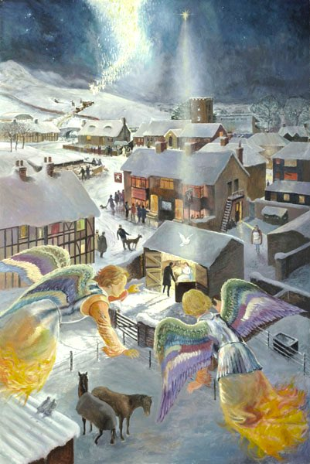

So letʼs take a moment to still ourself and enter the painting. Look around it carefully…
What captures your attention?
What are you drawn to?
Let your eyes hover over those places, along with the angels, for as long as you need to....
These are the words spoken to the shepherds on that first Christmas:
‘Donʼt be afraid. Iʼm here to announce a great and joyful event that is meant for everybody, worldwide: a Saviour has just been born in Davidʼs town, a Saviour who is Messiah and Master. This is what youʼre to look for: a baby wrapped in a blanket and lying in a manger.ʼ (from Luke 2 the Message version.)
This is what youʼre to look for….
2 fiery angels point the way to the stable and encourage us to focus on the family within. We seem to be ‘walking in the airʼ (snowman style) as we approach Bethlehem from above with them. Our birds-eye view across the snowy British landscape with pub and church reminds us that this is a journey of the imagination for us in our context. Our eyes are caught by different scenes and figures around the village. We could choose to fly over the area and explore whatʼs going on in the snowy streets but the angels hover in just one place, clearly pointing our way to the focus of the nightʼs events in the stable. ‘This is what youʼre to look for.ʼ
Pick and choose which questions are most helpful for you to ponder. This is not a school exam!
- How will you look for the baby Jesus in this season?
- Where do you hope to find him?
- What will you say to him when you find him?
- Letʼs try that again, what will you say to him if you are going to be utterly honest about how youʼre feeling right now?!
- Lots of people are enjoying life in the Star Inn. How easy would it be for us to miss what weʼre looking for? Will Covid-19 make it easier or harder to find our focus this Christmas?
- Only one person seems to have noticed whatʼs going on in the stable. If you were her, what would you be carrying and what would you do with it when you got to the manger?
- How can we, like the angels, point to this joyful event?
- For the young and young at heart -
- Can you find the name of the pub?
- Why do you think itʼs called that?
- Can you see a lost sheep that has been found?
- Do you know a story about that from the Bible?
- Whatʼs the name of the church?
- Do you know why thatʼs its name?
- Can you see a symbol of the Holy Spirit?
- What is lighting up the stable?
- How many angels can you count? Thatʼs a tricky one but, by the time youʼve tried, your grown up may be ready to move on from their praying!

